Login as Root Type **sudo –s**

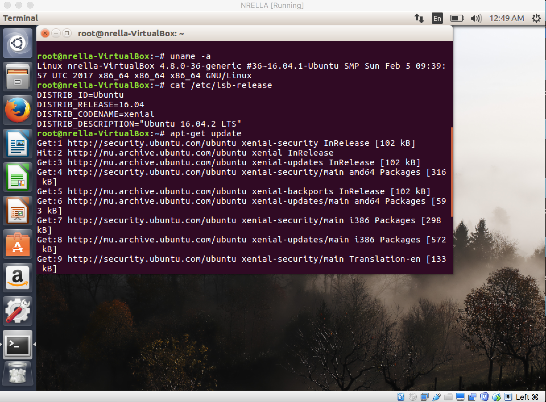

**apt-get upgrade**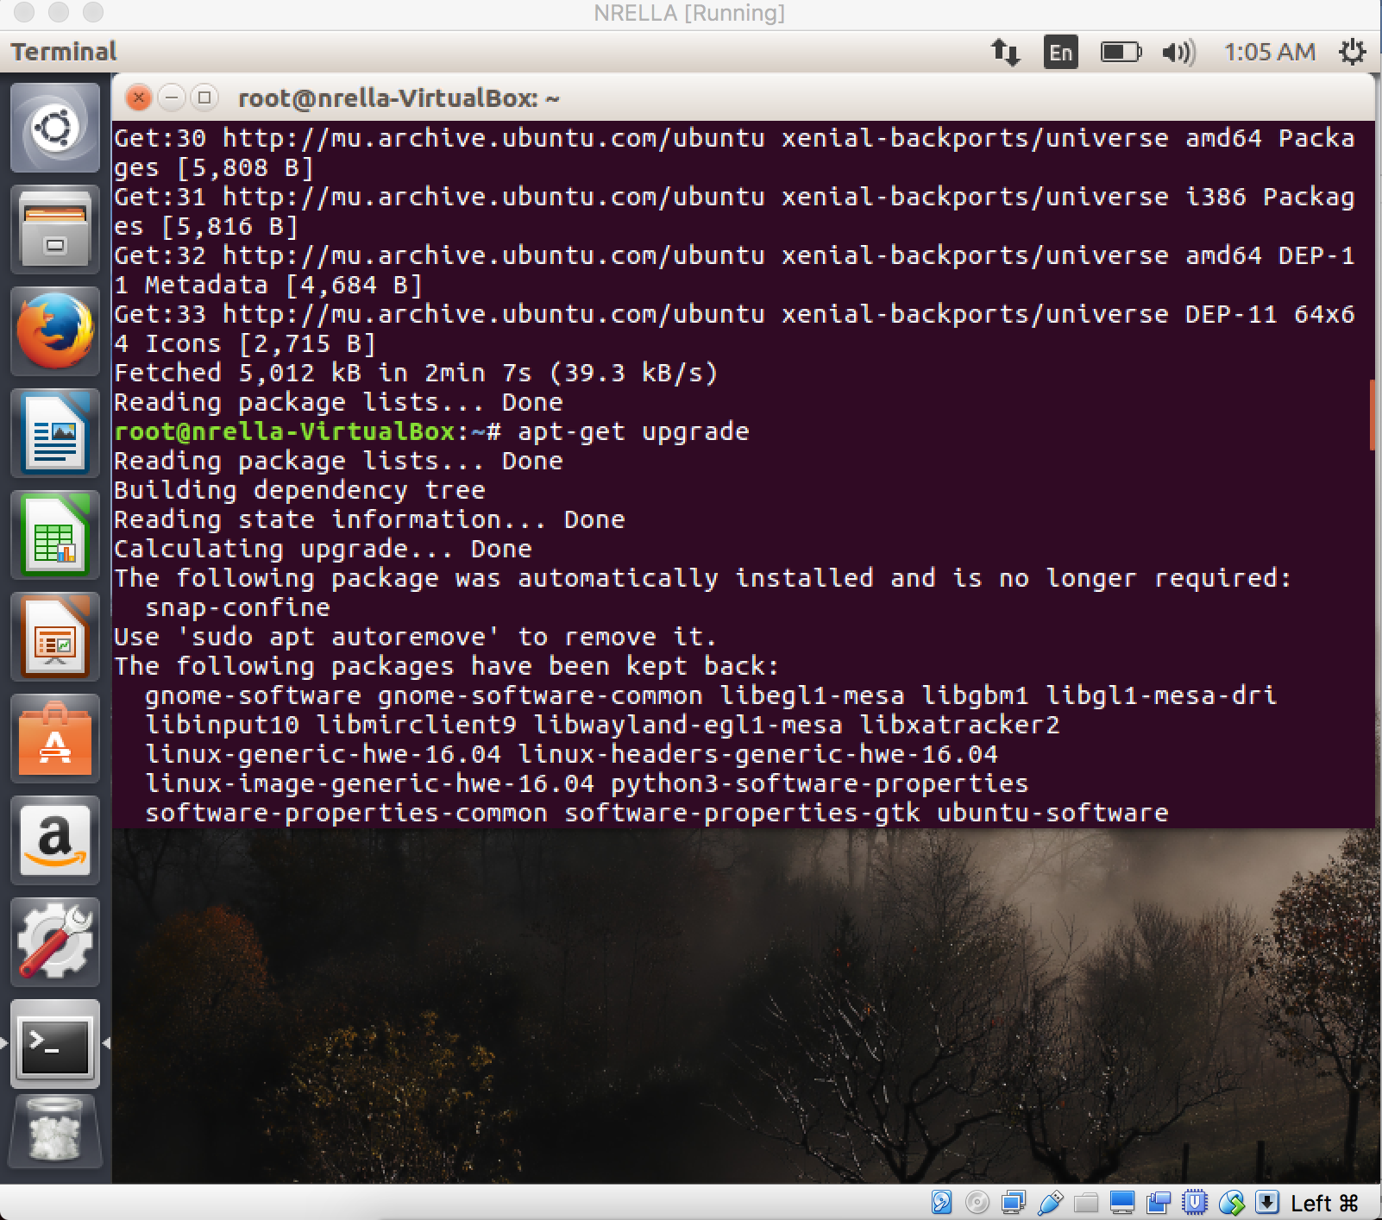

**apt-get install -y docker.io**

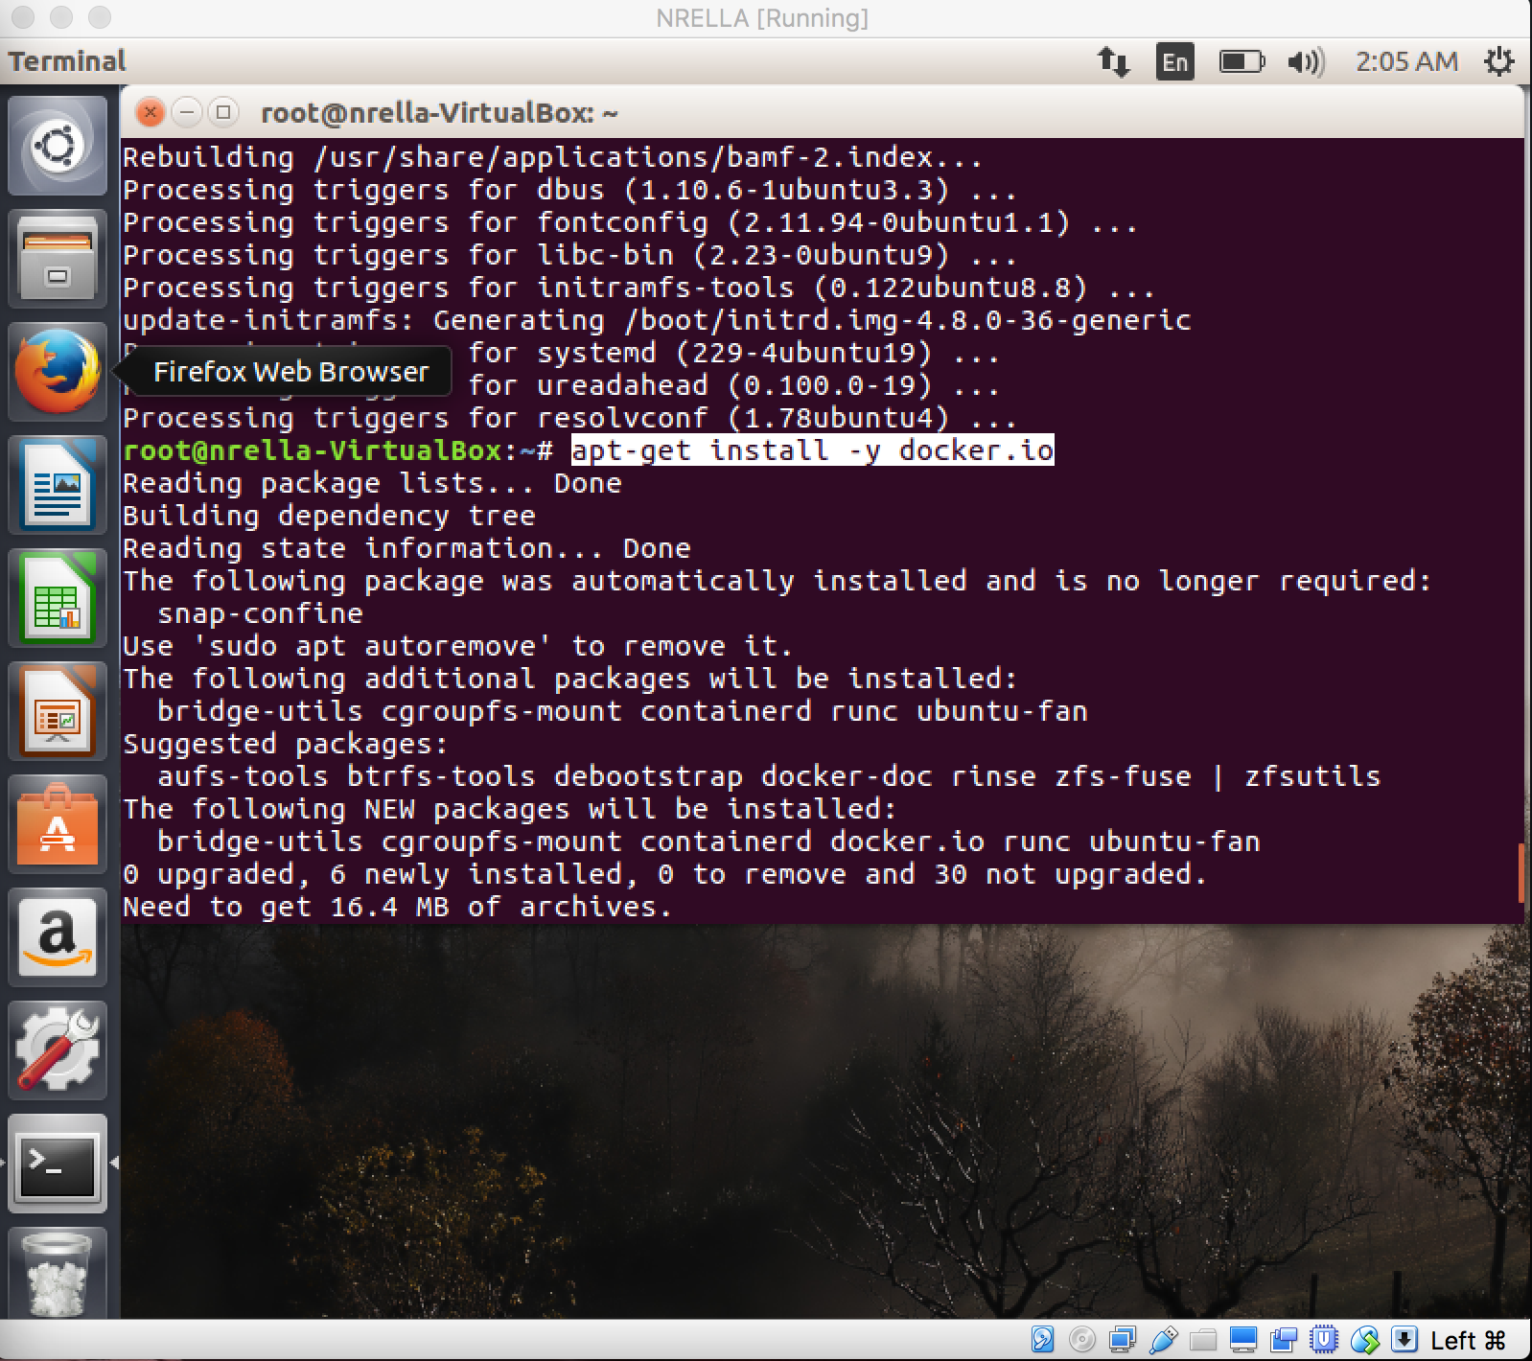

Wait until the installation has been completed, then you can start Docker with the *systemctl* command:

*systemctl start docker*

Enable docker to run at system boot:

*systemctl enable docker*

*docker version*

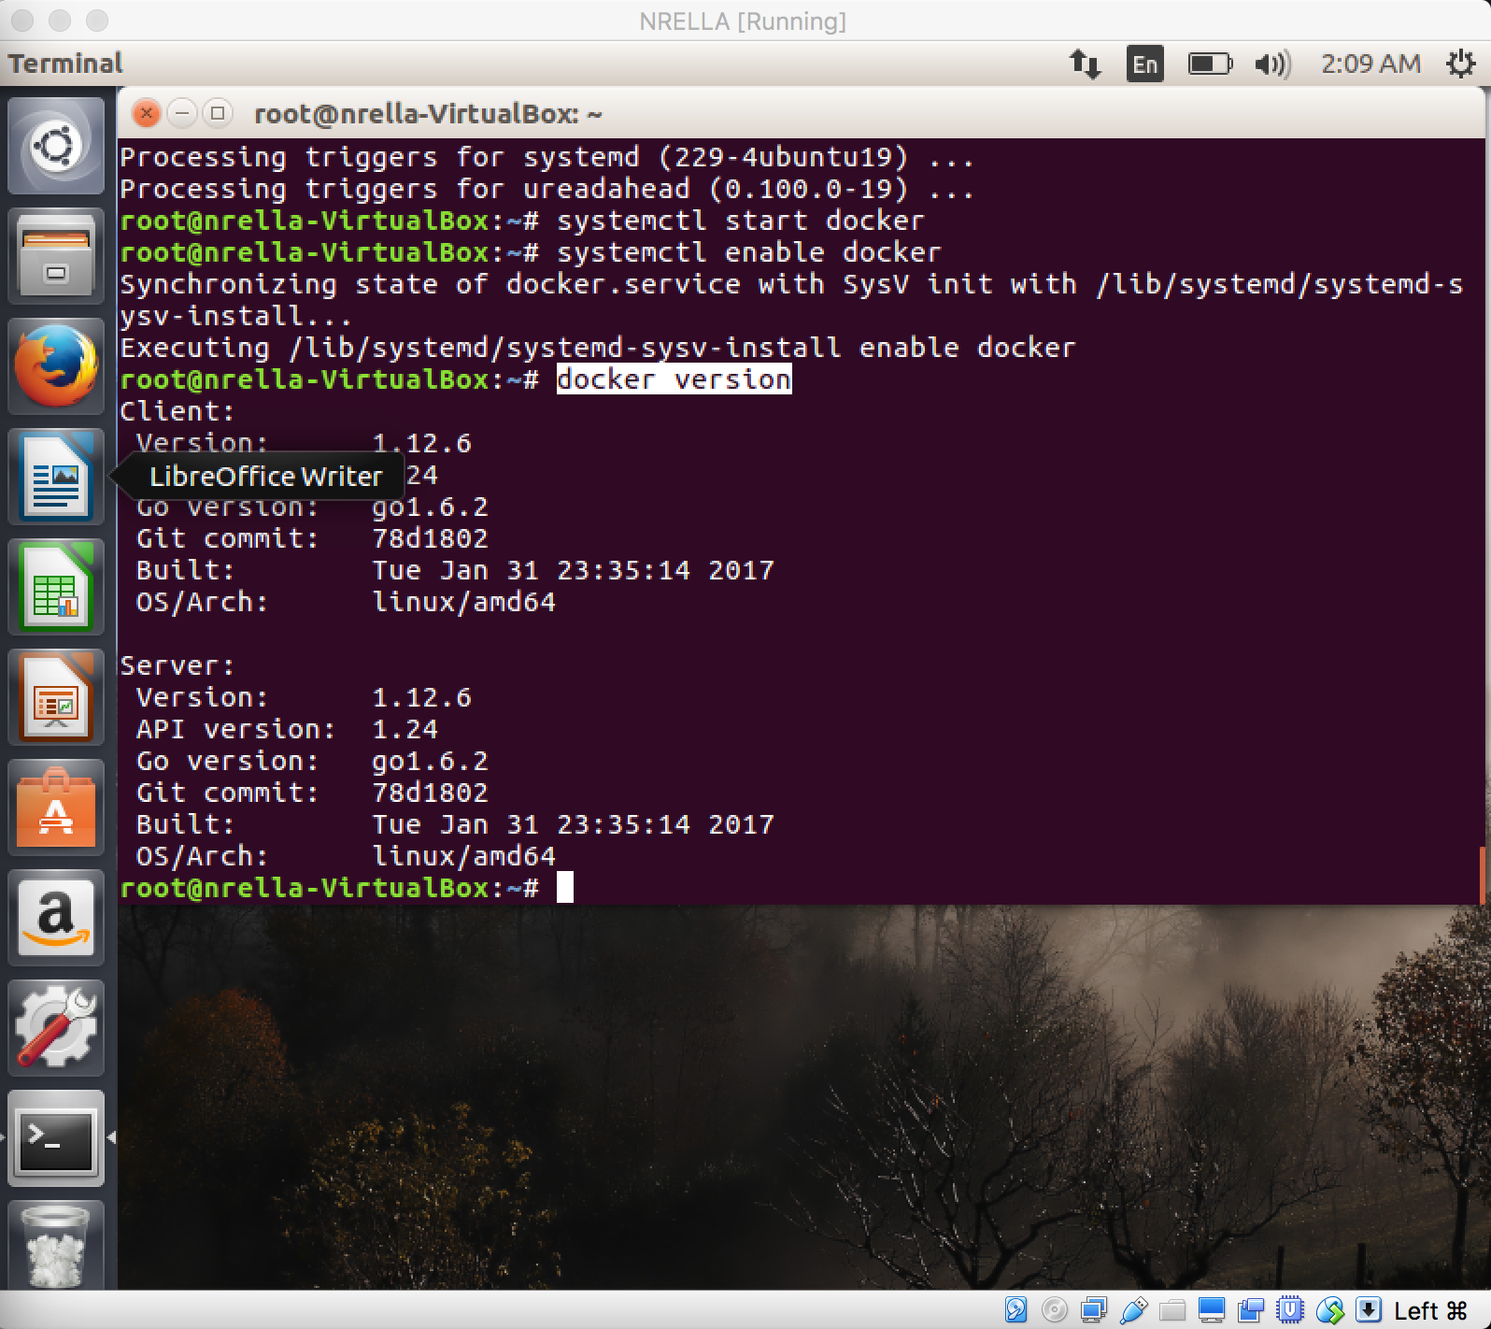

To create a new ***container***, you should start by choosing a base image with the OS, e.g. ubuntu

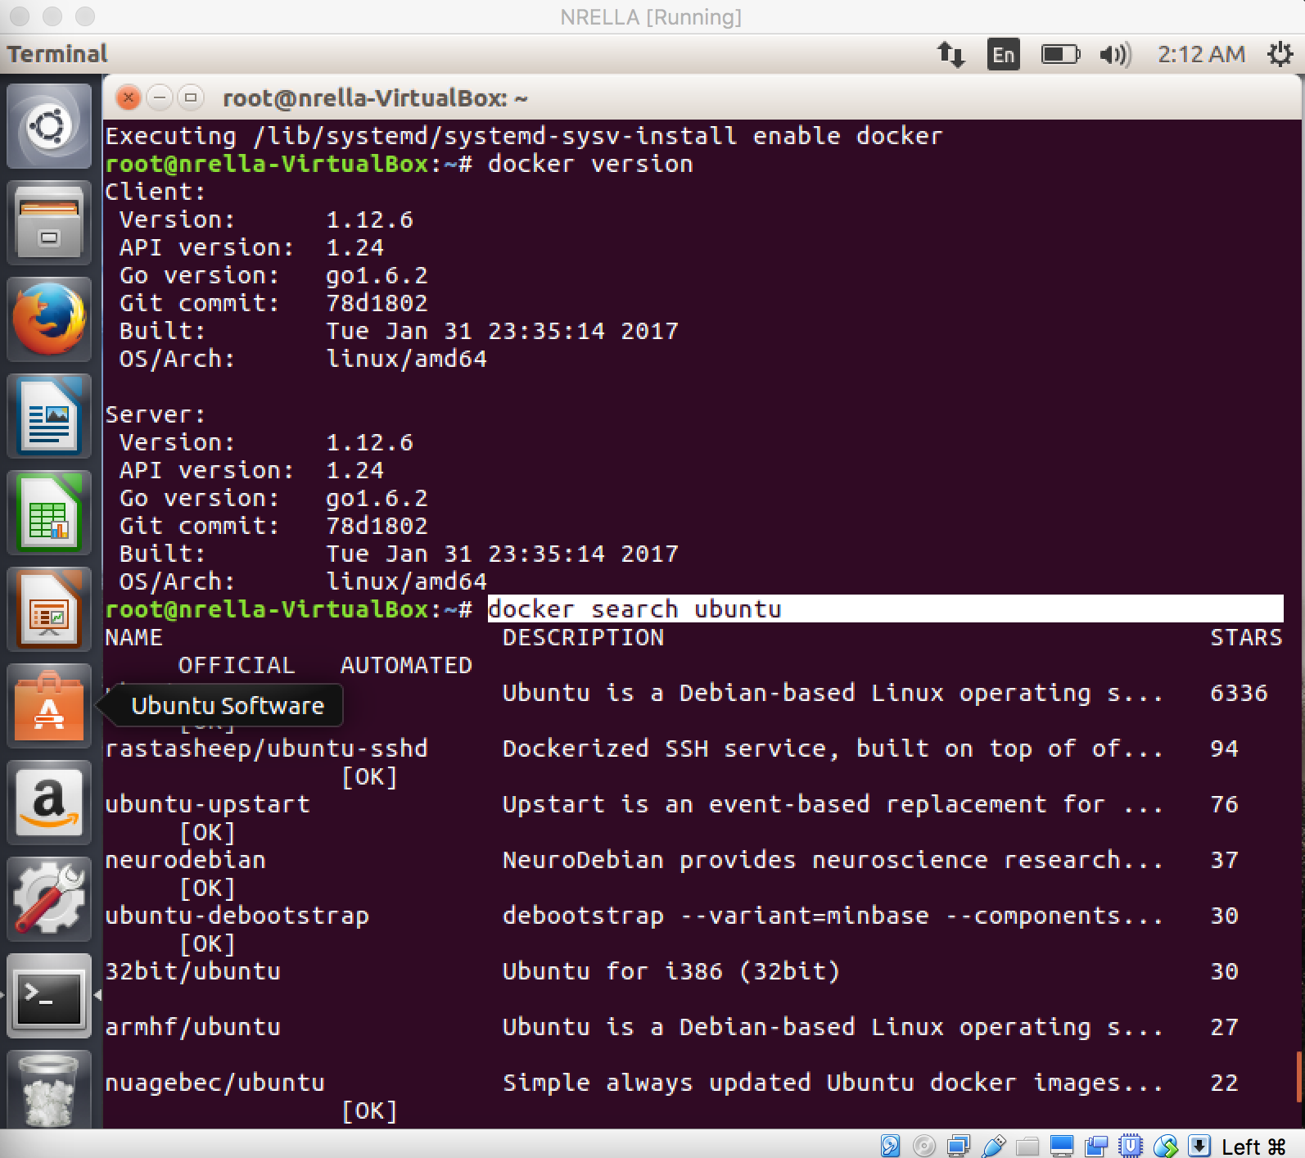

download the base image to our server, use the command:

**docker pull ubuntu**

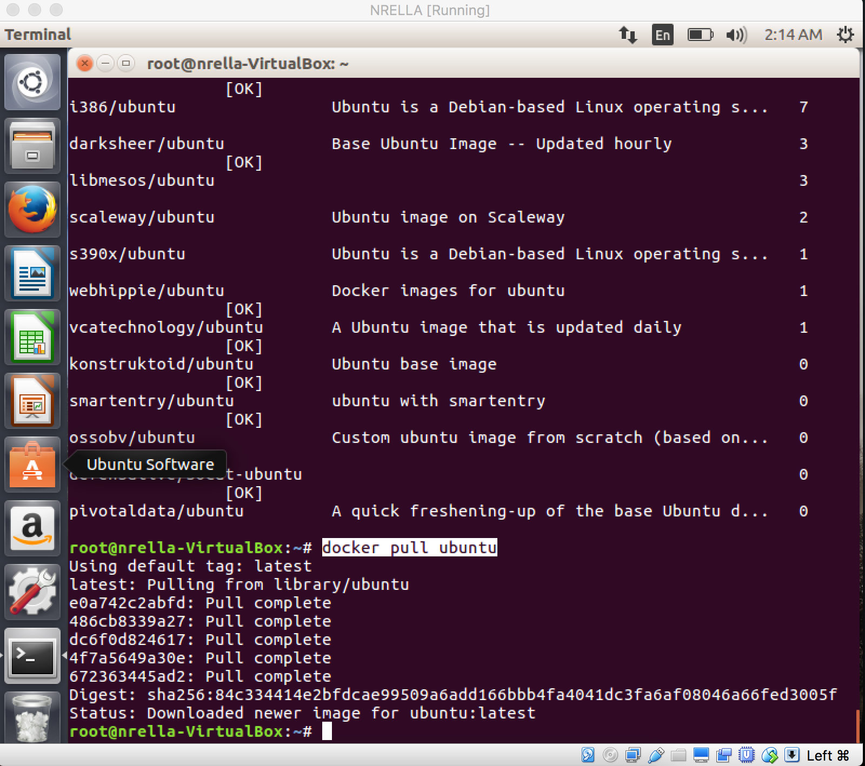

*docker run -i -t ubuntu:16.04 /bin/bash*

This command will create and run a container based in ubuntu 16.04 image and run a command */bin/bash* inside the container, you will be automatically inside the container after running the command.

The container will stop when you leave it with the command exit. If you like to have a container that is running in the *background,* you just need to add the *-d* option in the command.

*docker run -i -t -d ubuntu:16.04 /bin/sh -c "while true; do echo hello world; sleep 1; done"*

*/bin/sh -c "while true; do echo hello world; sleep 1; done"* this is bash script to echo ***"hello word"*** forever.

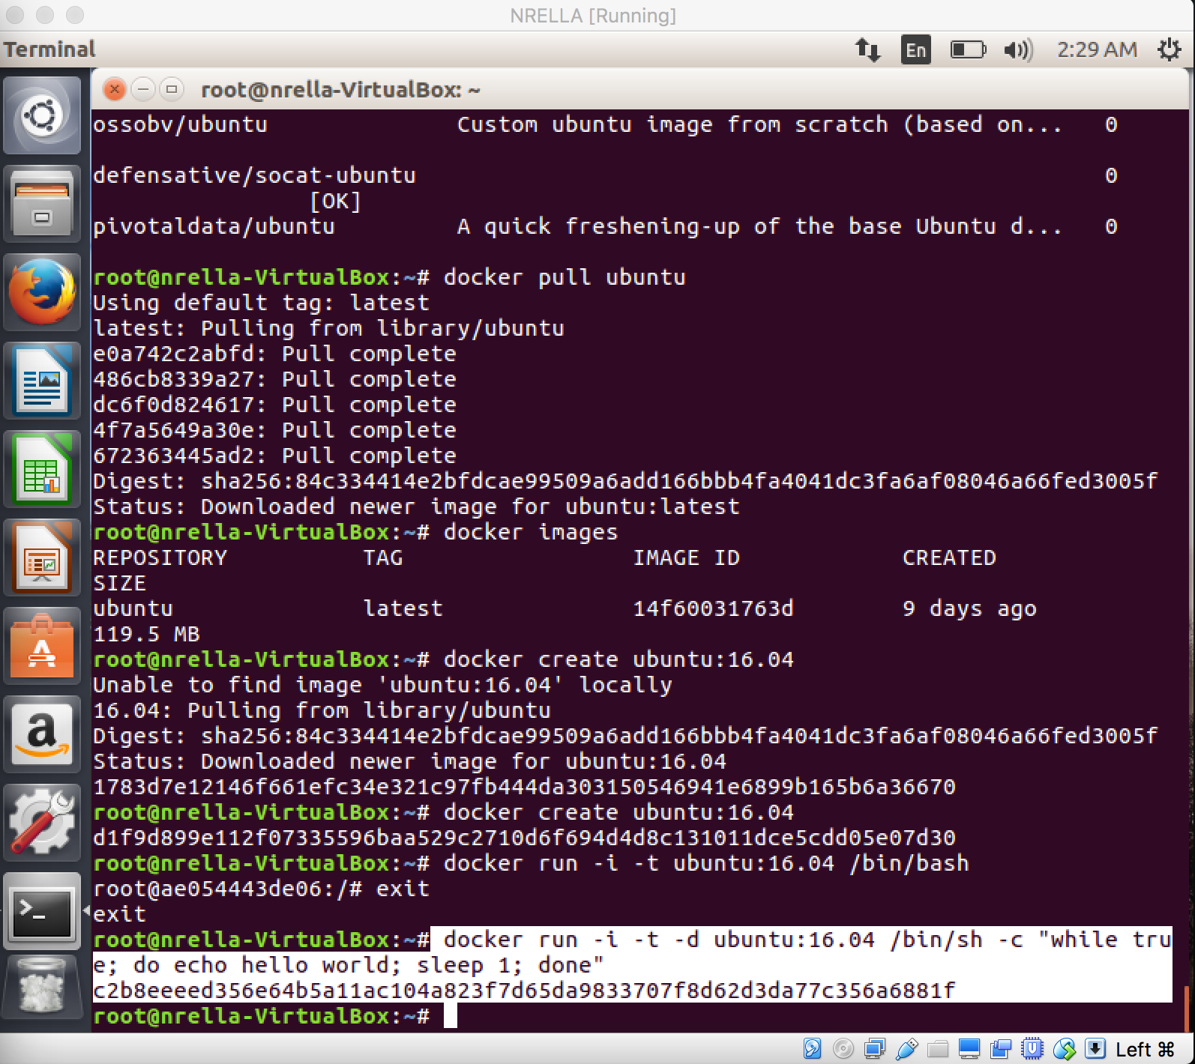

**docker logs c2b8eeeed356**

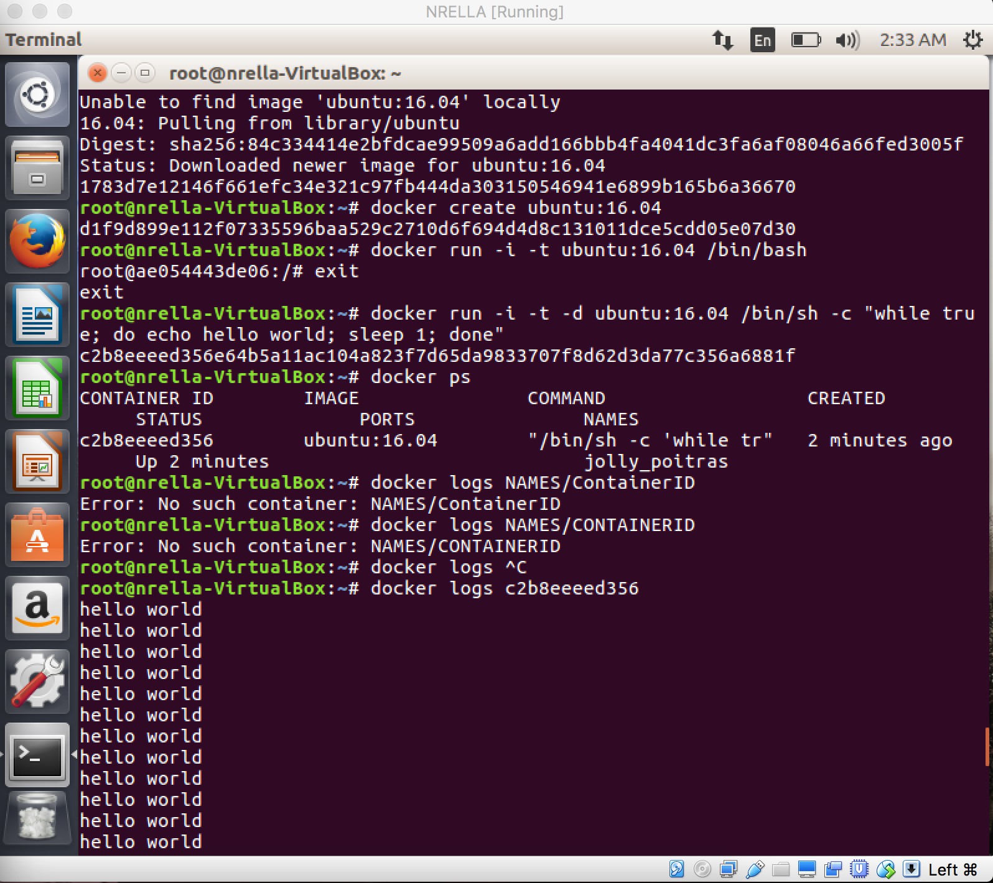

This command will connect you to the shell of the container:

*docker exec -i -t NAMES/ContainerID /bin/bash*

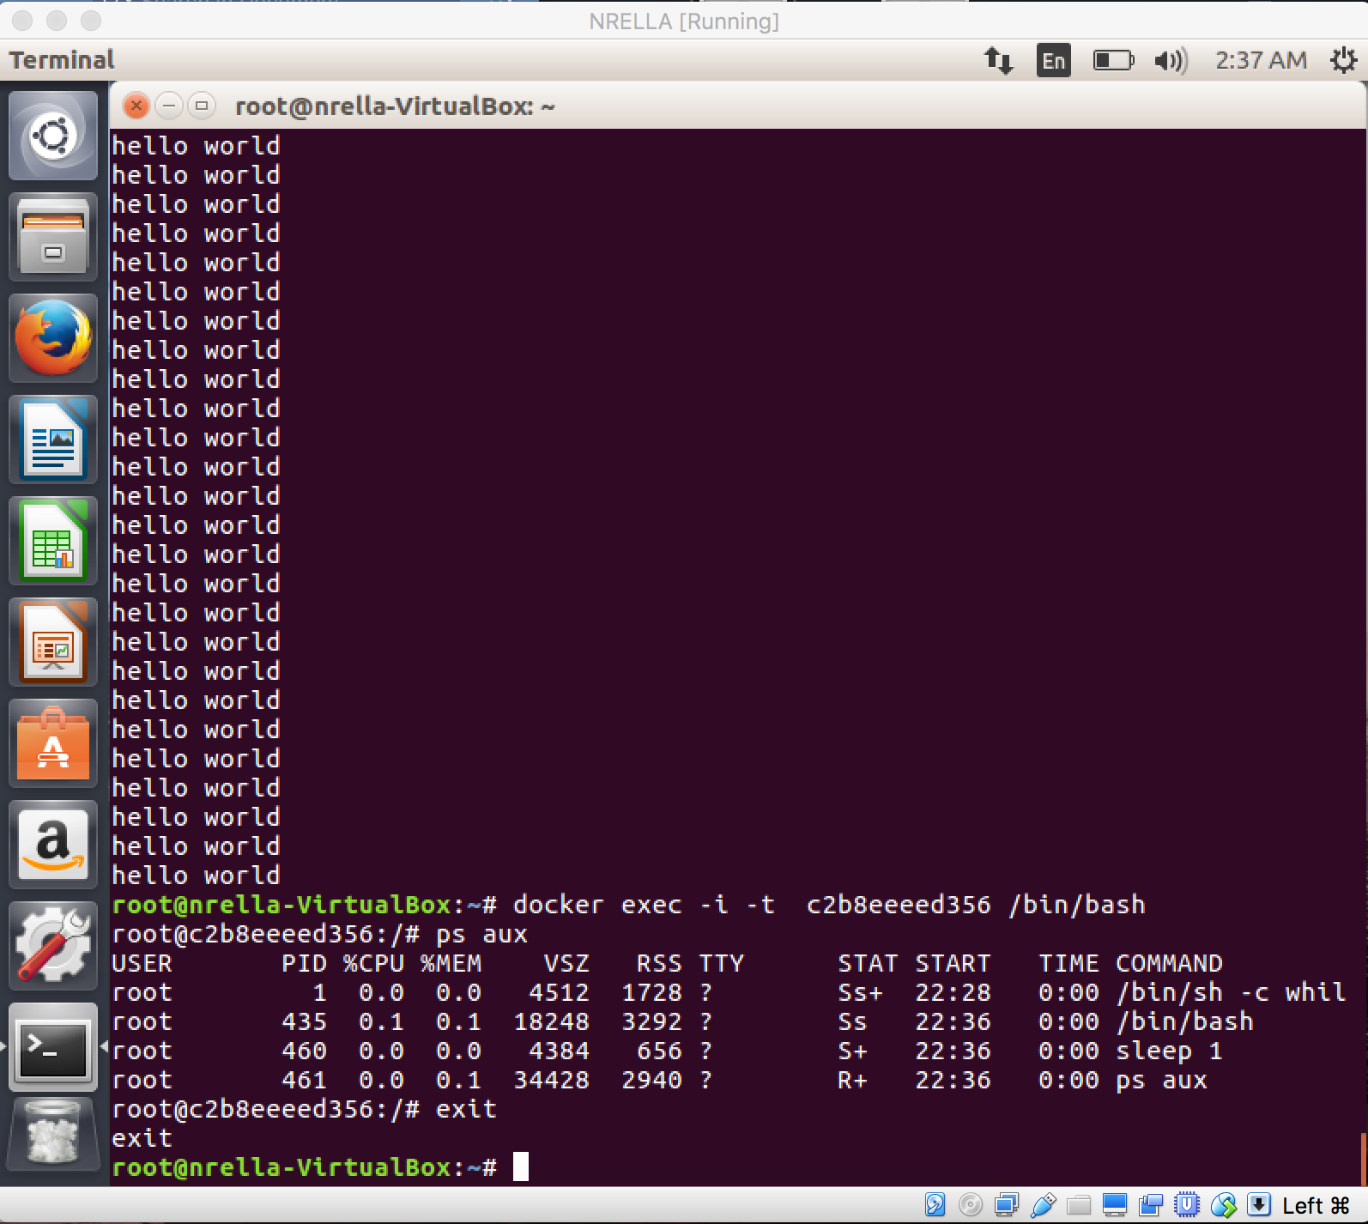

*docker stop NAME/ContainerID*

This will stop the container without deleting it, so you can start it again with the command:

*docker start NAME/ContainerID*

